

**University Modular Framework**

**Accounting & Finance Front Sheet**

**NB. This sheet must be attached to any submission of Accounting & Finance field module coursework made to the Student Assessment Office. No assignment will be accepted without it.**

Name of Candidate Tomasz Luty

Student Number 13427131

Title of Module ACC4006 Financial Planning Practice

Title of Coursework Financial Plan for Brian and Ella Mathews

Marking Tutor Mathew Aitchinson

Hand in Date 18th April 2016

Extension Granted to N/A

## Checklist before submission

1. Have you read, understood and acted in accordance with the referencing guidelines set out in the appropriate Accounting & Finance Module Guide.
2. *Where you have quoted directly from or where you have paraphrased the work of others, have you acknowledged and appropriately referenced the source of your quotation in the body of the text?*
3. *Have you placed all direct quotations in inverted commas?*
4. *Have you listed and correctly cited all your sources in your bibliography?*
5. **

|  |  |
| --- | --- |
|  | **2016** |
|  | Prepared For: Ella and Brian Mathews  Prepared By: Tomasz Luty  Date prepared: 20.04.2016 |

Table of Contents

**Disclaimer5**

**Letter of Engagement6**

**Base Plan Summary8**

**Personal Information9**

**Financial Planning Process10**

**Goals and Objectives11**

**Cash Flow12**

**Net Worth 15**

**Investment Attitude19**

**Recommendations23**

**Summary31**

**Appendices33**

**References37**

Figures presented in this report are based on the assumptions and information provided by the client. These information and assumptions may change over time. Some of the information in this report are based upon the current taxation rules and legislation. Therefore it is important that you review your financial plan frequently to ascertain information is accurate, up to date and concentrates on your needs. It is needed to look at different scenarios to help you understand impact of various assumptions on the objectives of the plan.   
  
Information presented in this report is only general and should you seek legal, accounting or tax advice, please contact your local tax, accounting or legal advisor.

Disclaimer

* This financial plan’s objective is to produce to you, my client, a better consideration of what you may expect from financial planning process, and obligations that follow within. In broad terms, the process consists of following steps: define terms of our relationship; discuss your goals and gather information about your finances; evaluate the situation based on the information you provided; produce and present financial plan for your consideration; implement partly or solely strategies outlined in this plan; monitor and amend the information if required.

Letter of Engagement

* I am required to disclose any interest that may interrupt me from providing neutral advice. I have no conflict of interest and if any should arise, it will be brought to your attention immediately.
* I am obligated by my profession to keep your information in secret and will not release the information without your written confirmation, or unless required by law. This information will not be used regardless of any benefit that may be obtained
* I am able to advice in general about life insurance and any insurance related services such long-term care, critical illness insurance or annuities. However, if you would require a specific insurance policy, you must seek an insurance broker that deals with specific type of policies.
* It has been agreed that Brian Mathews and Ella Mathews must arrive at all meetings and that actions can only be executed following their unified confirmation. We have agreed that telephone advice will not be considered.
* Before making any recommendation, I have to have complete overview of your current position of your finances. Information I need contracts with, but are not resctricted to, include: your assets, your liabilities, cashflow, expense amount or anticipated inheritance, benefits, insurance and other aspects mentioned in this financial plan
* When taking to account different financial positions available in your particular situation, I may have to make one or more assumptions. These assumptions may be, but not restricted to, your expected age of retirement, expected mortality, income needed for retirement, state benefits, time spectrum, additional needs, rates of return and inflation as well as tax rates. Any assumption made by myself are realistic and reasonable, and they will be given to you in writing further in this financial plan

Letter of Engagement

* Having revised your financial position, I will produce a financial plan for you to review. When presenting this plan to you, I will do it in the way so that you can understand what’s in there: pros and cons of different approaches and cost of them, risk involved with your plan, time sensitivity of recommendations as well as consequences of no action taken, impact of changes to the plan and impact of changes in assumptions. The client is required to inform the advisor of any misunderstanding.
* It is agreed that the review meeting will be conducted every 12 months.
* The advisor will keep the client with up-to-date information via email or post as chosen by the client. Should any information regarding financial position arise, the client is responsible to deliver them as soon as possible.

Date:________________

________________

Brian Mathews

_________________

Ella Mathews

__________________

Tomasz Luty CFP, Financial Advisor  
University of Northampton

**Net worth Cash flow**

Base Plan Summary

Total assets £493,700 Family income (after taxes) £48,267  
Total Liabilities £105,000 Total Expenses £38,541 Your Net Worth £388,700 Your net cashflow £9,726

**_______________________________________________________________  
  
Asset Allocation Profile** Current Recommended

Cash 14% 10%  
Bonds 6% 6%  
Property 71% 71%  
Equities 6% 10%  
Other 3% 3%

**_______________________________________________________________**

**Retirement Plan**

Income required £35,000   
Current pension total value £78,200  
Annuity 3% value required £1,166,667Fund shortfall/surplus **-£1,104,967**

**_______________________________________________________________  
  
Life Insurance Needs** Brian Ella

Total Capital Required £35,000 £35,000  
Less current capital £30,784 £14,917  
Life insurance need **£4,216 £20,083**

**_______________________________________________________________  
  
Disability Insurance Needs** Brian Disabled Ella Disabled

Total annual income sources £14, 917 £30,849  
Less annual expenses £31,541 £31,541Disability Insurance need  **£16,624 £692  
_______________________________________________________________**

**Education planning**

Amount required £304,120   
Length of income required 16 years

Personal Information

**Personal**

First Name Brian Ella  
Last Name Mathews Mathews  
Date of Birth 13/06/1967 25/05/1969   
Age 49 47  
Marital Status Married Married  
Employer Sedgmoor & Co Summer, Pill & Co  
Occupation Architect Assistant

**_______________________________________________________________  
  
Location**

Street 36 Elm Tree Close   
City Solihull  
Borough Metropolitan Borough of Solihull  
Post Code B91 2NS  
Country United Kingdom  
Contact Information:  
Phone 0121 336633  
Email   
**_______________________________________________________________  
  
Dependants**

First Name Last Name Date of Birth Age  
Alice Mathews 01/02/2004 12  
Philip Mathews 30/03/2007 9   
Adrian Mathews 01/05/2010 5

**_______________________________________________________________  
  
Wills**

Do you have a will? Yes

**_______________________________________________________________  
  
Insurance**

**No life insurance in place  
_______________________________________________________________  
  
Notes**Brian is due to receive £100,000 from his recently deceased mother’s estate via her will.

The financial planning process consists of 6 steps which are developed to help You, the Client achieve Your financial goals and objectives. So at the start I shall define our relationship, in which we will discuss frequency of our meeting as well as how I will be paid. After agreeing to terms and conditions I have to gather data about about you, This data also includes your goals and time we have to achieve your objectives. After gathering Your data I will develop a financial plan for you which will reflect your current personal and financial situation. Following this analysis I will produce to you the recommendations and action plan as of when and what you should do, and eventual alternatives that you could have. This recommendation will also include information about how you should protect yourself against unexpected circumstances such as death or disability. After deciding which plan is most optimal for you we will implement it. To ensure we are on the right track with your finances, I suggest meeting with you annually on the date which later will be specified.

Financial Planning Process

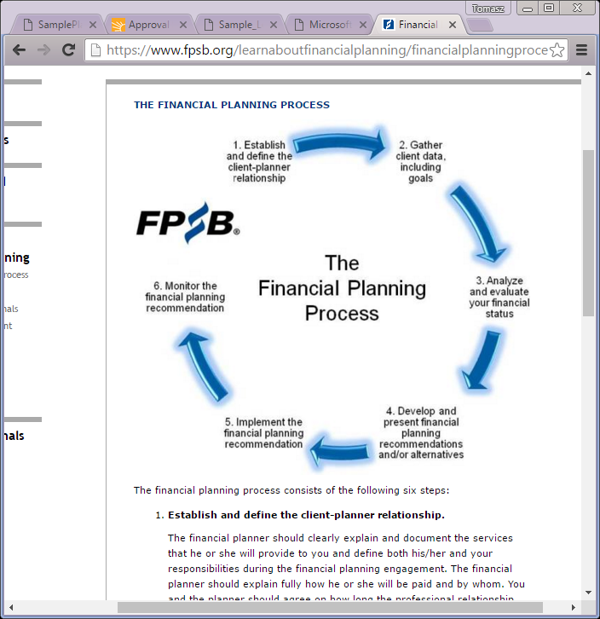

Source: FPSB (2016)

* Secure Your family for income of:

Your Goals and Objectives

On your death £35,000 pa.   
 On Ella’s death £35,000 pa.  
 On Your or Ella’s disability £35,000 pa.

* Fund Your children’s education
* Plan for Your retirement required income £35,000 pa.
* Plan and manage your investments
* Plan your estate
* Save from income

Recommendations put in place were adapted to let you afford specific solutions like life insurance or savings from income. The recommendations will be prepared to fill the financial gaps that you may experience now or in the future.

Being in charge of your financial affairs requires a budget or cash flow profile. Keeping your budget on your sight helps tracking your expenses and keeping a sense of where your money goes out to and helps you achieve your goals and objectives. It does not matter whether it’s saving for a house, trying to invest, or simply being prudent to be ready for unexpected. It also gives you some other benefits as you have complete control over how and when you spend your money, you can identify opportunities that lie within your budget, but also it can help you earn extra money with good budgeting as it enables you to invest in different types of property, stocks and other investment opportunities. This is how your cash flow looks at the moment:   
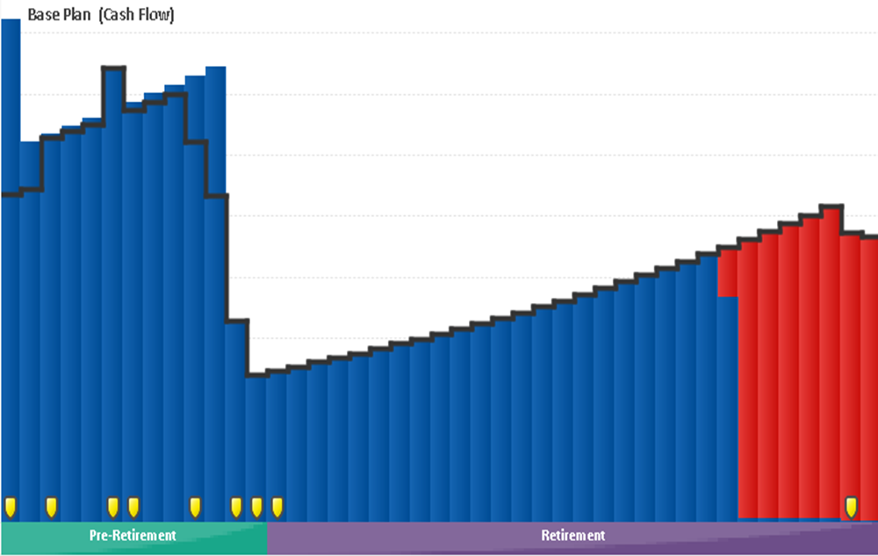

Cash Flow Statement

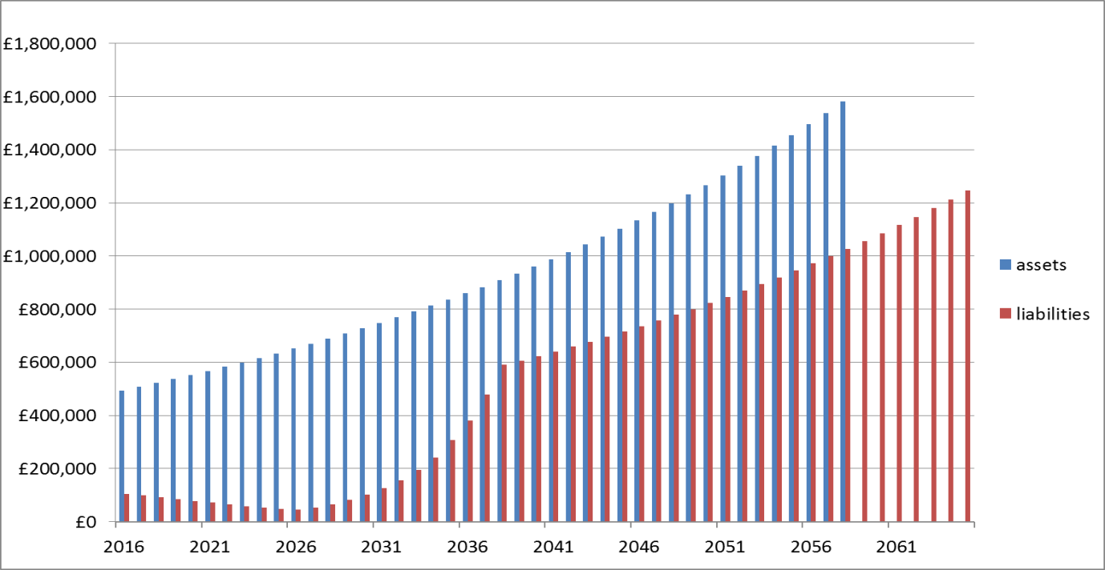

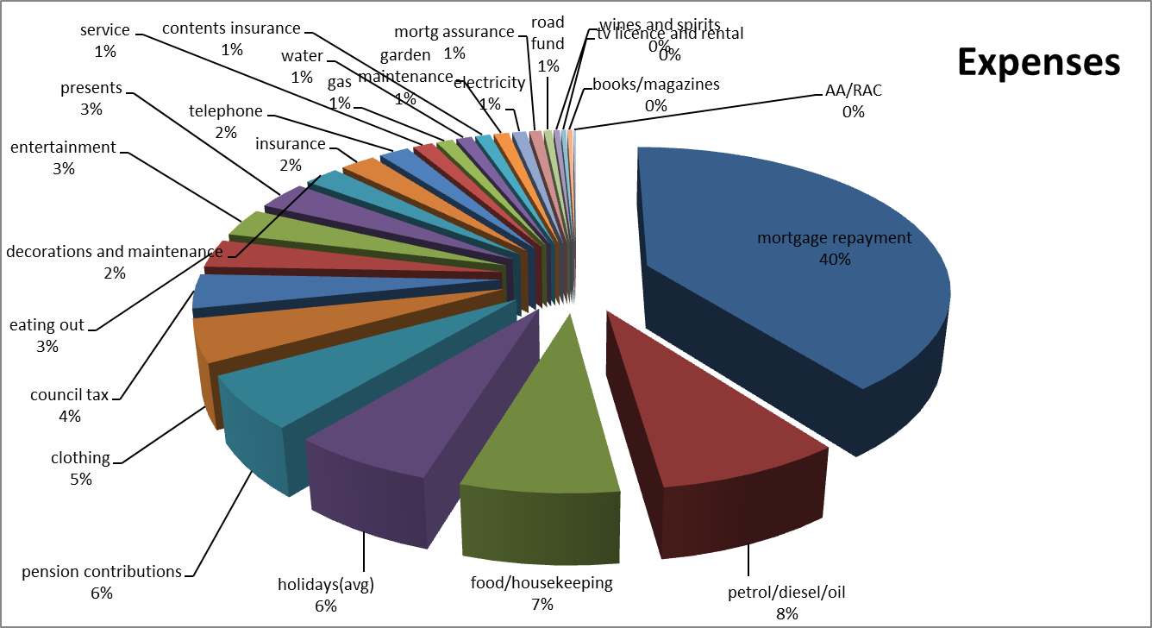  
 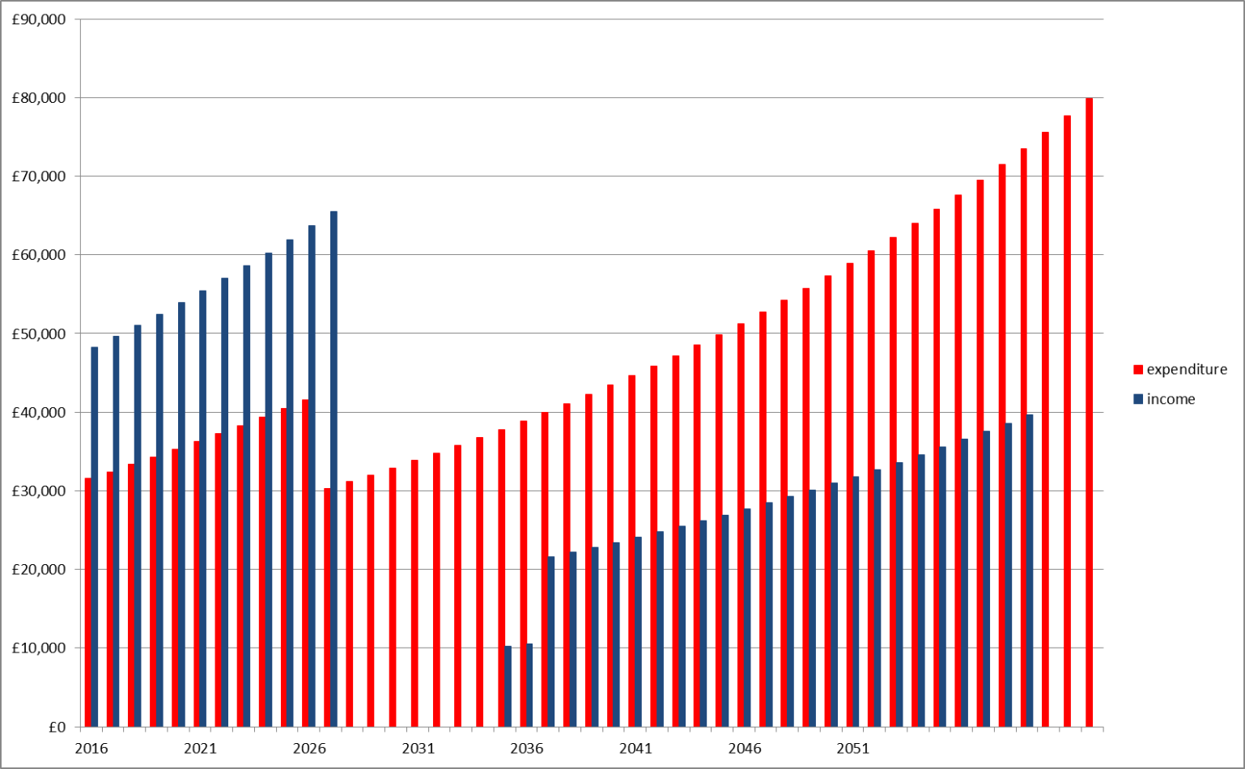

Cash Flow Detail

**Income Annual Percentage**

Cash Flow Detail

Family Income (pre-tax) £61,000 95.9% Child Benefit £2,501 4.1%  
Taxes and Deductions £15,727 25%

**_______________________________________________________________**Total £48,267 75%   
**_______________________________________________________________**

**Expenses**

Mortgage Repayment £12,494 39.6%   
Education £7,000 18.2%  
Petrol/diesel/oil £2,580 6.7%  
Food/Housekeeping £2,200 5.7%   
Holidays (average) £2,000 5.2%  
Pension Contributions £1,875 4.9%  
Clothing £1,500 3.9%  
Council Tax £1,200 3.1%  
Eating Out £1,000 2.6%  
Entertainment £1,000 2.6%  
Presents £1,000 2.6%   
Decorations and Maintenance £700 1.8%  
Insurance (car) £700 1.8%  
Telephone £600 1.6%   
Service (car) £400 1.0%  
Gas £330 0.9%  
Water £312 0.8%  
Contents Insurance £300 0.8%   
Garden Maintenance £300 0.8%   
Electricity £276 0.7%  
Mortgage Assurance £240 0.6%  
Road Fund £160 0.4%   
Wines and Spirits £120 0.3%   
Tv License and Rental £100 0.3%   
Books/Magazines £100 0.3%   
AA/RAC £54 0.1%

**____________________________________________________________________**  
**Total Expenses** £38,541 100%

**Net Cash Flow £9,726**

Why preparing Net Worth Statement?   
  
Your net worth gives you an overview of your current financial situation. In financial terms, it’s your assets deducted by your liabilities. Your net worth is your point of reference, so you can analyse and see how far you are from your financial goals, so you can proceed further in terms of your finances. Ativa (2016) specifies few areas that are important for net worth:  
  
Money Management:  
If you have a clear idea of what you own and what you owe as well as have better control over your income and expenditure. Net worth statement will give you the best overview of your asset allocation, debt, but also most liquid assets as best sources of cash

Net Worth Statement

Insurance Planning:  
By determining your net worth, you will find out how much protection you need in case something goes wrong.

Expenses:   
Knowing how much net worth you have can also help you allocate additional expense commitments, which in your case is education funding for you children.

Retirement Planning:  
Having an overview of your financial assets and liabilities, the advisor can decide how much, in your case, and how long you will have to fund your retirement before you reach your retirement age.

Investment Planning:  
Knowing your net worth, you can oversee where and how much of your assets are invested into specific valuables.

Estate Planning:  
Knowing what assets you have and what you owe to your creditors, it is important that you plan your what and to whom you give money   
  
Savings:  
Having in mind how much surplus income you have a strong thought of saving may come to your mind

Financial Planning:  
For financial planning net worth is essential part of it. The reason why it is so important is that your advisor, knowing how much of surplus assets and income you have, can help you reach your financial goal by adjusting specific parts of your finance rather than use external funding sources.

**All Assets and Liabilities:** total Brian Ella  **Assets:**Property £350,000 £175,000 £175,000  
Cash £25,000 £20,000 £5,000  
ISA £22,700 £21,600 £1,100  
Shares £21,000 £15,000 £6,000  
Deposits £20,000 £10,000 £10,000   
Bonds £20,000 £10,000 £10,000  
Valuables £15,000 £15,000  
Savings £10,000 £10,000 Trusts £10,000 £6,000 £4,000

Net Worth Statement as of 12.04.2016

**_______________________________________________________________  
Total Assets £493,700** £257,600 £236,100  
**_______________________________________________________________**

**Liabilities:** TotalBrian Ella  
Mortgage £100,000 £50,000 £50,000   
Credit Card £5,000 £2,000 £3,000

**_______________________________________________________________  
Total Liabilities £105,000** £52,000 £53,000

**_______________________________________________________________**  
**Your Net Worth: £388,700**

**_______________________________________________________________**

**Pension Assets*:** total Brian Ella

Occupational Pension £69,691 £59,298 £10,393  
Preserved Pension Funds £42,000 £26,200 £15,800   
**_______________________________________________________________  
Total Pension Assets**  **£111,691** £85,498 £26,193

*They are outside of net worth because they are not ready-usable assets

Your asset and liabilities allocation, showed graphically to help you understand, are distributed as following:  
  
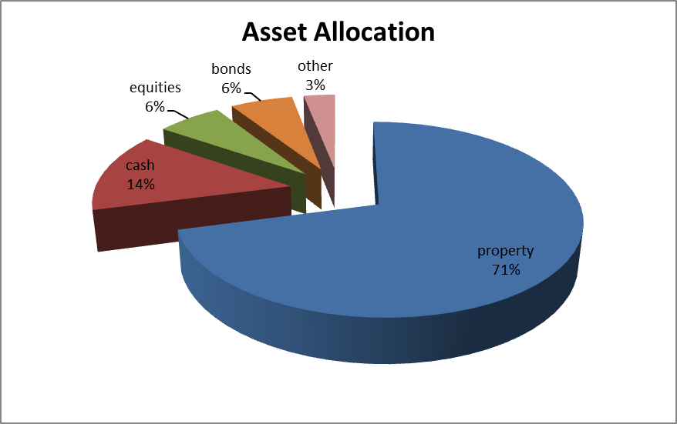

Net Worth Continued

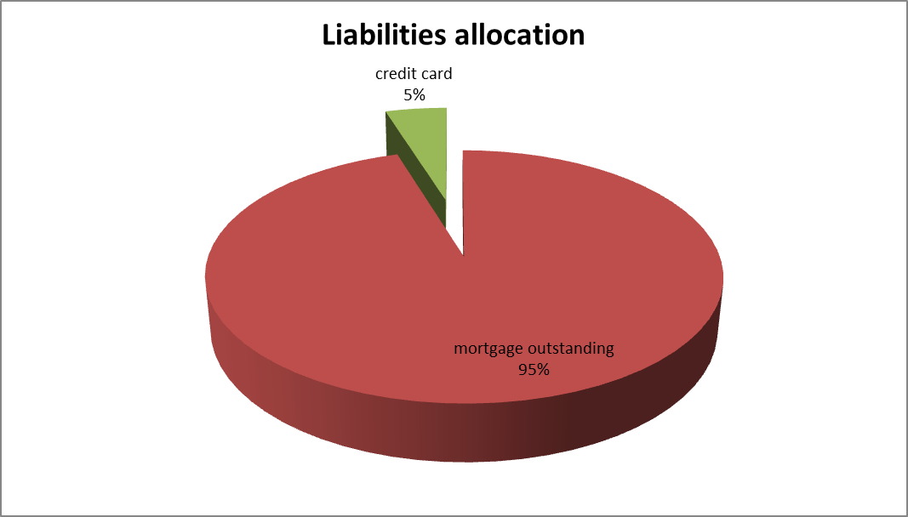

My comments regards your current Net Worth are as following:

Net Worth Continued

* You own a property, which is very good for your portfolio, as you have possibility of downsizing, or you can wait with selling part of your property until you reach specific age, ie. To boost your retirement income or allocate it to for different purpose
* You specified to me, that you want to retire at age of 60 along with your spouse, however what is clearly visible is that you don’t have enough funds in your occupational pension. Along with that, another problem is that the state pension begins to be paid, according to Gov.uk (2016) timetable, the age you will have to reach before you get your State Pension is 67, therefore You will have to fill the gap of 7 years for you and 9 years for Ella before you will start receiving it.
* You have children and want to fund their education, this is a serious commitment that will require you to use your cash balance to pay for this
* You have protection, however you have to increase it in case you or Ella becomes disabled or dies, because you will have insufficient income

Before I break down the recommendations analysis, I have state certain facts. I prepared few questions for you and you answered them as following:

Investment Attitude

1. Are you prepared to accept that capital/contrinutions may fall in value and, if so, with how much of your capital can you afort to risk a short term fall in the value in pursuit of medium to long term growth?  
   **Brian and Ella: Yes, up to 50%**
2. Of this amount, how much would you wish to invest in higher risk investments where there may the prospect of higher returns but also a risk of long-term capital loss?  
   **Brian and Ella: Up to 20%**
3. How much of your capital/contributions do you require access to and over what timescale?  
   **Brian and Ella: School fees and retirement as already stated**
4. How much of your capital/contributions do you need to protect against inflation and over what timescale?  
   **Brian and Ella: As much as possile to achieve goals**
5. How much of your capital/contributions do you wish to generate growth and if so what rate(s) and over what timescale?  
   **Brian and Ella: As much as possile to achieve goals**
6. Does this apply to any special purposes, if not please explain any differences in approach?  
   **Brian and Ella: No, details already given.**

The box below says that, according to definitions, shows in detail how much risk and to what categories it applies

Investment Attitude Continued

|  |  |  |  |  |
| --- | --- | --- | --- | --- |
| Risk attitude and investment/asset type | Retirement (pension schemes | Long term investment over 15 years | Medium term investment and saving 5-15 years | Short term savings up to 5 years |
| No risk to capital |  |  |  | Brian and Ella |
| Low Risk |  |  |  |  |
| Modest Risk |  |  | Brian and Ella |  |
| Relatively higher risk | Brian and Ella | Brian and Ella |  |  |
| High risk |  |  |  |  |

No risk to capital – no risk of capital value and accept possible loss of real value due to inflation.

Low risk – Low risk loss of capital of capital but some inflationary risk to real value or return based on fixed rate.

Modest risk – Generally small risk of real or comparative capital loss in pursuit of longer-term capital growth.

Relatively Higher Risk – Some risk of real or comparative capital loss in pursuit of longer-term capital growth.

High risk – High risk of capital loss in pursuit of growth.

Investment Attitude Continued

To present to you what kind of investments we could use, I suggest a small illustration:

  
Source: Monevator (2016)

According to the illustration, different asset classes can give you different types of returns. Obviously the more risk you take the more return you achieve. Approximately, according to market averages, you can reach rate of returns as following:

* Cash – 0.5% to 1.5%
* Bonds – 3% to 4%
* Property – 5% to 8%
* Equities – 7% to possibly 50%

When choosing the right investment strategy, few factors have to be taken into account. From the cube of investment approaches, we have to take to account that your agepreference goes towards rather safer investments like bonds or eventually property. In your case, illiquidity is rather not considered as you need a good pension accumulation within next 12 years.

Investment Attitude Continued

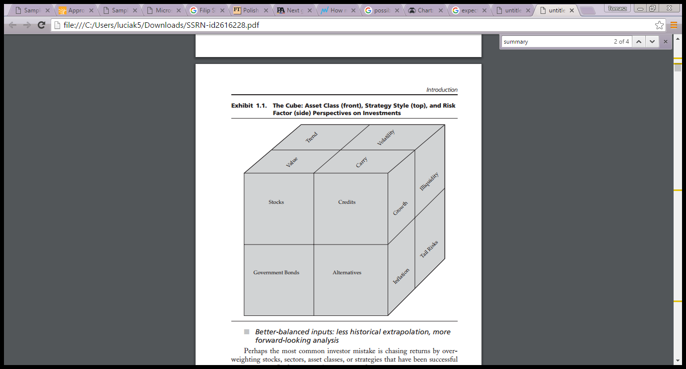

Source: Ilmanen (2012)

My recommendations are based on the assumptions in the markets, however, as mentioned earlier, it may change at the time. However, my recommendations can be summarized with following points and will be followed by analysis of each of them:

Recommendations

* Use inheritance of £100,000 to pay off the mortgage. Pay off the credit cards from surplus income
* Create emergency fund
* Buy a first death life insurance policy of £400,000
* Use your cash to increase investments
* Wait with retirement and invest surplus cash into pension

Note: I took certain assumptions when creating your multi year forecasts. Some of these assumptions are based on the market.

1. Pay off your liabilities using the £100,000 inheritance from your mothers estate and your credit cards using cash in the bank balance.  
     
   Paying off your mortgage would enable you to invest into your pension. By paying off this debt, you would save £12,494 annually. By paying off your credit cards, your liabilities would not increase anymore. Following these actions, your expenses would be looking as following:  
      
    Annual Percentage   
     
   Education £7,000 25.8%  
   Petrol/diesel/oil £2,580 9.5%  
   Food/Housekeeping £2,200 8.1%   
   Holidays (average) £2,000 7.4%  
   Life Insurance £1,884 7.0%  
   Clothing £1,500 5.5%  
   Income Protection £1,274 4.7%  
   Council Tax £1,200 4.4%  
   Eating Out £1,000 3.7%  
   Entertainment £1,000 3.7%  
   Presents £1,000 3.7%   
   Decorations and Maintenance £700 2.6%  
   Insurance (car) £700 2.6%  
   Telephone £600 2.2%   
   Service (car) £400 1.5%  
   Gas £330 1.2%  
   Water £312 1.2%  
   Contents Insurance £300 1.1%   
   Garden Maintenance £300 1.1%   
   Electricity £276 1.0%  
   Road Fund £160 0.6%   
   Wines and Spirits £120 0.4%   
   Tv License and Rental £100 0.4%   
   Books/Magazines £100 0.4%   
   AA/RAC £54 0.2%   
   **______________________________________________________**  
     
   **Total expense £27,090**  
   **_________________________________________________________  
     
   Net Cash Flow £16,239**

Recommendations in detail

1. Create Emergency Fund  
     
   Purpose of the emergency fund is to have your expenses covered whilst you would be sick or unable to work. The most appropriate is to have from 3 to 12 months of expenses. However, Wong (2016) says that you may not need emergency fund if you have no debt, adequate insurance and high difference between expenses and earnings. You don’t have this so I would suggest 3 months of your monthly expenses to be taken off from your cash and put into savings account. Your emergency fund, after paying off the mortgage would be in amount of: **£4761.** You could leave in the savings account of 1% and the situation would look as following:  
     
   Year Balance  
   **_________________________________________________________**  
   2016 £4,761  
   2017 £4,809  
   2018 £4,857  
   2019 £4,905  
   2020 £4,954  
   2021 £5,004  
   2022 £5,054  
   2023 £5,104  
   2024 £5,155  
   2025 £5,207  
   2026 £5,259  
   2027 £5,312  
   2028 £5,365  
   2029 £5,418  
   2030 £5,473  
   2031 £5,527  
   2032 £5,583  
   2033 £5,638  
   2034 £5,695  
   2035 £5,752  
   2036 £5,809  
   2037 £5,867  
   2038 £5,926  
   2039 £5,985  
   2040 £6,045  
   2041 £6,106  
   2042 £6,167

Recommendations in detail

Recommendations in detail

1. Buy life insurance policy on first death with critical illness for £340,000. Buy Income protection policy for income of £2,400/month  
     
   You said you want to protect your family against disability and death of either you or your spouse. You said you need income of £35,000 in todays money, however you need relatively high return. My solution for you in this case is to take payout and invest in the property trust with dividend yield of 5% and approximate growth of 4% annually. Alternatively to save you worry I suggest you to invest the payout in this fund: [Bluefin Solar Income Fund (2016)](http://www.hl.co.uk/shares/shares-search-results/b/bluefield-solar-income-fund-limited-ord-npv) Growth of 3% annually and dividiend yield of 7% sounds optimal. However, to strengthen the portfolio I suggest the diversification with [Barclays Bank PLC (2016)](http://www.hl.co.uk/shares/shares-search-results/0087025) and [Bankers Investment Trust (2016)](http://www.hl.co.uk/shares/shares-search-results/0087177) Funds. Details of cost of the Life are put in the Appendix 1. Details of how your income would look like, are as following:  
     
   In case when Brian dies or becomes disabled:  
     
     
   Year Investment Income Salary Income Total  
   **_________________________________________________________**  
   2016 £28,600 £14,171 £42,771  
   2017 £29,421 £14,56 9 £43,990  
   2018 £30,30 3 £14,97 9 £45,68 2  
   2019 £31,21 3 £15,40 0 £46,612  
   2020 £32,14 9 £15,83 2 £47,981  
   2021 £33,11 3 £16,27 7 £49,931  
   2022 £34,10 7 £16,735 £50,482  
   2023 £35,13 0 £17,20 5 £52,333  
   2024 £36,18 4 £17,68 8 £53,782  
   2025 £37,26 9 £18,18 55 £55,455  
   2026 £38,38 7 £18,69 6 £57,804  
   2027 £39,53 9 £19,22 2 £58,671  
   2028 £40,72 2 £19,76 2 £60,847  
   2029 £41,947 £20,31 7 £62,624  
   2030 £43,20 5 £20,88 8 £64,904  
   2031 £44,502 £21,47 5 £65,977  
   2032 £45,837 £22,07 9 £67,915  
   2033 £47,212 £22,69 9 £69,911  
   2034 £48,628 £23,33 7 £71,96 5  
     
     
     
     
     
     
   In case Ella stops dies or becomes disabled:  
     
   Year Investment Income Salary Income Total  
   **_________________________________________________________**  
   2016 £28,600 £27,78 2 £56,382  
   2017 £29,421 £28,563 £57,984  
   2018 £30,30 3 £29,36 6 £59,66 9  
   2019 £31,21 3 £30,191 £61,40 3   
   2020 £32,14 9 £31,03 9 £63,18 8   
   2021 £33,11 3 £31,91 1 £65,205  
   2022 £34,10 7 £32,80 8 £66,195  
   2023 £35,13 0 £33,73 0 £68,860  
   2024 £36,18 4 £34,67 8 £70,682  
   2025 £37,26 9 £35,65 2 £72,922  
   2026 £38,38 7 £36,65 4 £75,041  
   2027 £39,53 9 £37,68 4 £77,223  
   2028 £40,72 2 £38,743 £79,648  
   2029 £41,947 £39,83 2 £81,779  
   2030 £43,20 5 £40,951 £84,156  
   2031 £44,502 £42,10 2 £86,603  
   2032 £45,837 £43,28 5 £89,121  
   2033 £47,212 £44,50 1 £91,71 3  
   2034 £48,628 £45,751 £94,37 9  
     
     
     
     
     
   Cost of the policies is as following:   
   - For Brian cost of Income Protection is £90.3 with deferred period of 60 days   
    (Appendix 2)  
   - For Ella Cost of Income Protection is £35.89/month with deferred period of 90 days (Appendix 3)  
   - Cost of Life Policy with Critical Illness is specified in Appendix 1

Recommendations in detail

1. Use your cash to increase investments   
     
   I would suggest taking the Building Society Deposit of £20,000 and invest in [Bluefin Solar Income Fund (2016)](http://www.hl.co.uk/shares/shares-search-results/b/bluefield-solar-income-fund-limited-ord-npv) fund as I presented to you in case of insurance payout. It would provide you some extra income and details would look as following:  
     
   Year Investment Income Salary Income Surplus/Deficit  
   **_________________________________________________________**  
   2016 £2,694 £45,76 6 £23,031   
   2017 £2,802 £47,75 2 £23,710  
   2018 £2,914 £48,37 4 £24,409 2019 £3,031 £49,73 4 £17,523  
   2020 £3,152 £51,13 1 £18,052  
   2021 £3,278 £52,56 8 £10,556  
   2022 £3,409 £54,04 5 £19,158  
   2023 £3,545 £55,56 4 £19,712  
   2024 £3,867 £57,12 5 £20,308 2025 £3,835 £58,73 0 £20,922  
   2026 £3,988 £60,38 1 £21,538  
   2027 £4,148 £62,07 7 £31,685  
   2028 £4,313 £63,82 2 £28,312  
   2029 £4,486 £65,61 5 £29,107

Recommendations in detail

1. Pay for children education using surplus income.   
     
   You can pay for your children education from the surplus income you have. Details of how income would have to be distributed is as following:  
     
   

Recommendations in detail

1. Wait with retirement and invest more part of your salary into pension  
     
   You told me at the beginning you and Ella would like to retire when you reach the age of 60. You specified in the fact find that you are able to take slightly higher risk to invest in the pension therefore we used it and chose the right pension fund for you which is [Legal & General Pension](http://www.fundslibrary.co.uk/fundslibrary.dataretrieval/documents.aspx?user=landgdoc&type=custom_field.www_landg_co_uk.factsheet_SHD&sedol=3052138) (2016), which had average growth of 4% within last 5 years, therefore I assume it would grow enough in time to provide you income for retirement.  
   However, the problem is that you don’t have enough pension assets at the moment and therefore you will have to wait until you are 64 to begin your retirement with the income you specified. In 2033, with pension pot of £1,183,532 (details are in Appendix 4), you could get annual income of £34,322 when buying an annuity of rates available in the market. I would suggest for you to buy a joint life 50% RPI escalated annuity, so when either you or Ella die prematurely, you would still have access to income and it would rise as the time goes on. To do so, you must sacrifice 21% salary both you and your wife until you retire. Details of income would be distributed looks as following:  
   

Recommendations in detail

After providing you with specific recommendations with what to do with your finances, I am happy to provide you with details of the plan as following:

**Net worth Cash flow**

Summary

Total assets £493,700 Family income (after deductions) £43,329  
Total Liabilities £0 Total Expenses £27,090  
Your Net Worth £493,700 Your net cashflow £16,239

**_______________________________________________________________  
  
Asset Allocation Profile** Adjusted

Cash 10%   
Bonds 6%  
Property 71%  
Equities 10%  
Other 3%

**_______________________________________________________________**

**Retirement Plan**

Income required £35,000   
Current pension total value £78,200  
Fund Value in 2033 £822,397  
Difference between houses £400,443  
Total value £1,222,840  
Annuity Annual Income £35,462  
Retirement Age (Brian and Ella) 65 and 63

**_______________________________________________________________  
  
  
  
  
  
  
  
  
  
  
  
  
  
Insurance Needs**

Policies Needed: Life insurance with  
 Criticical illness  
 Income protection

Policy payout: £320,000 for life insurance

Cost of Policies: Life policy £157 per month  
 Income Protection £106 per month **_______________________________________________________________  
  
  
Education planning**

Summary Continued

Amount required £304,120  
Length of income required 14 years  
Source of income Surplus income, or if insurance pays out, investment  
  
Your Cashflow, after all amendments including cost of insurance policies, looks as following:

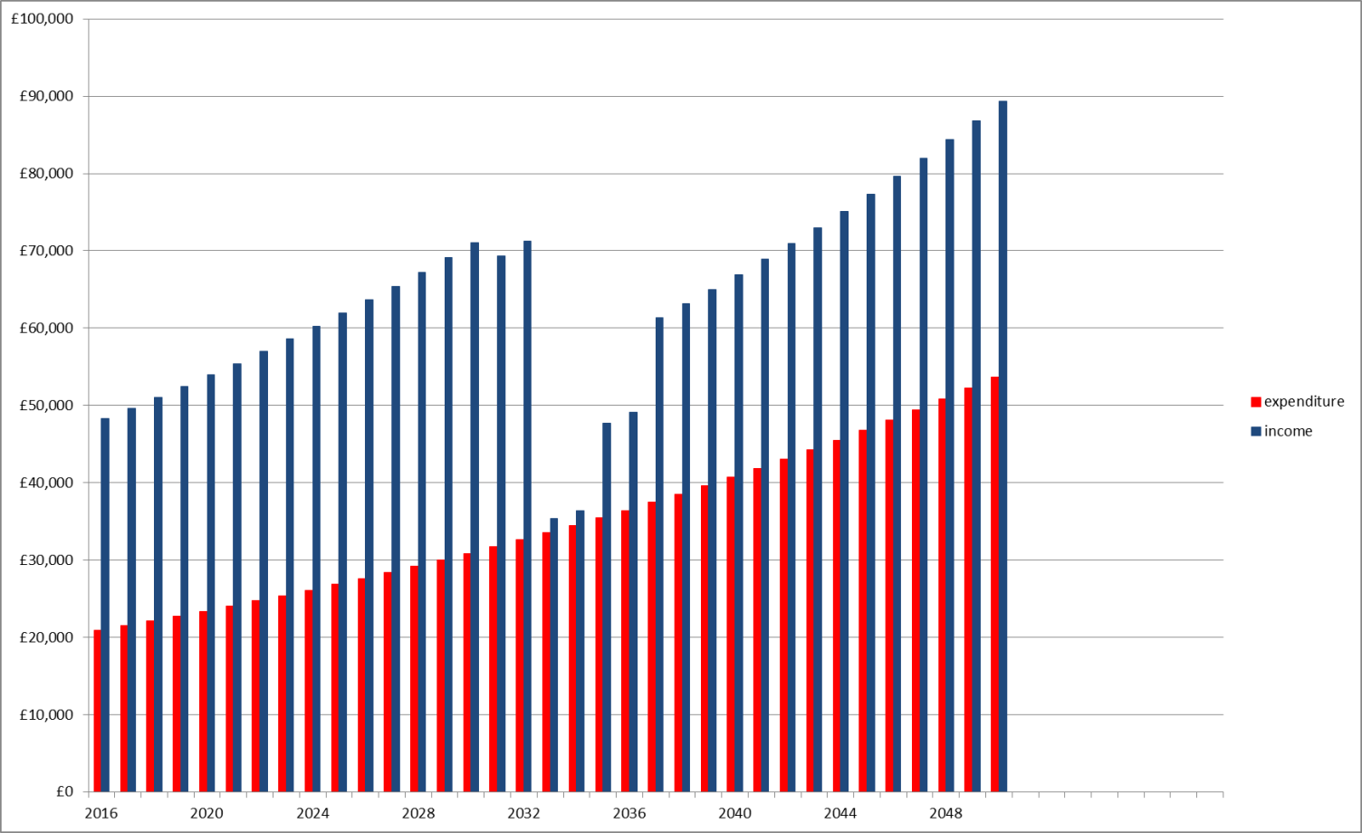

Appendices

Appendix 1: Life Insurance

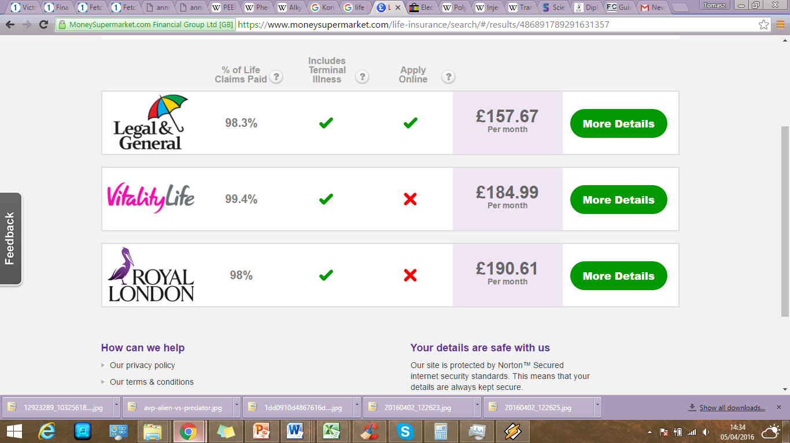  
Source: Money Supermarket (2016)  
  
  
  
Appendix 2: Income Protection for Brian

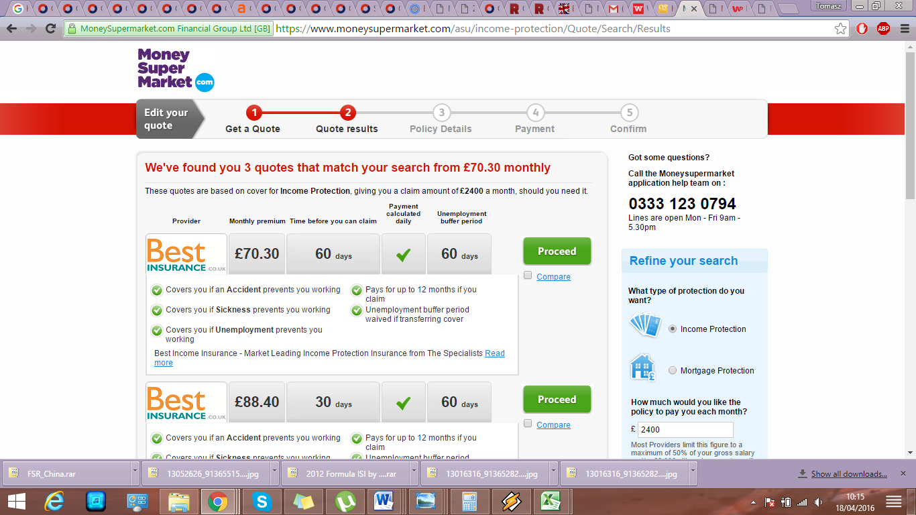  
Source: Money Supermarket (2016)

Appendix 3: Income Protection for Ella

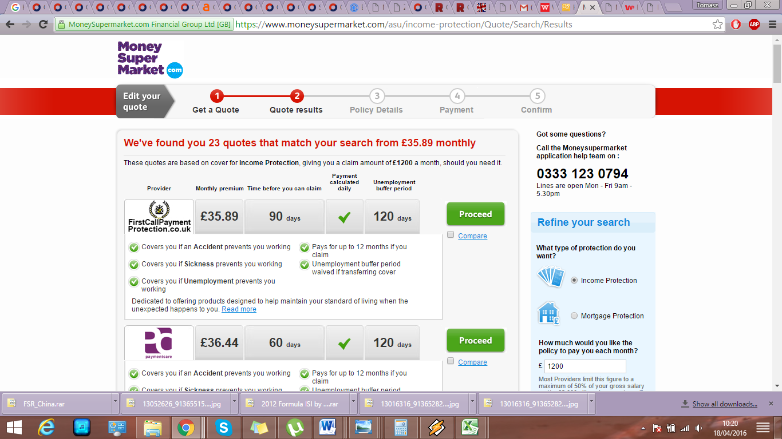  
Source: Money Supermarket (2016)  
  
  
  
Appendix 4: Pension Calculation  
  
Step 1. Average pension growth 5 year average  
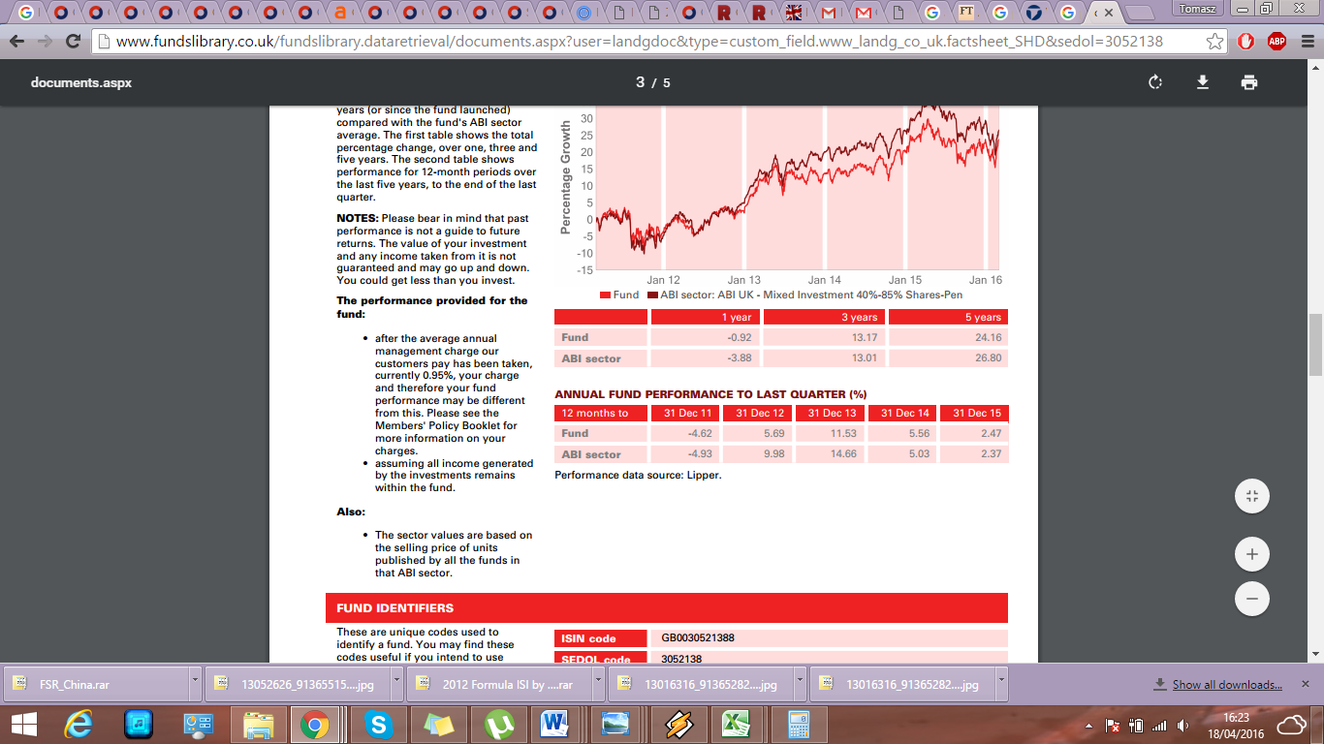  
Source: Legal And General Pension (2016)  
  
Step 2. Future value formula: Pension growth average was 4% within last 5 years   
 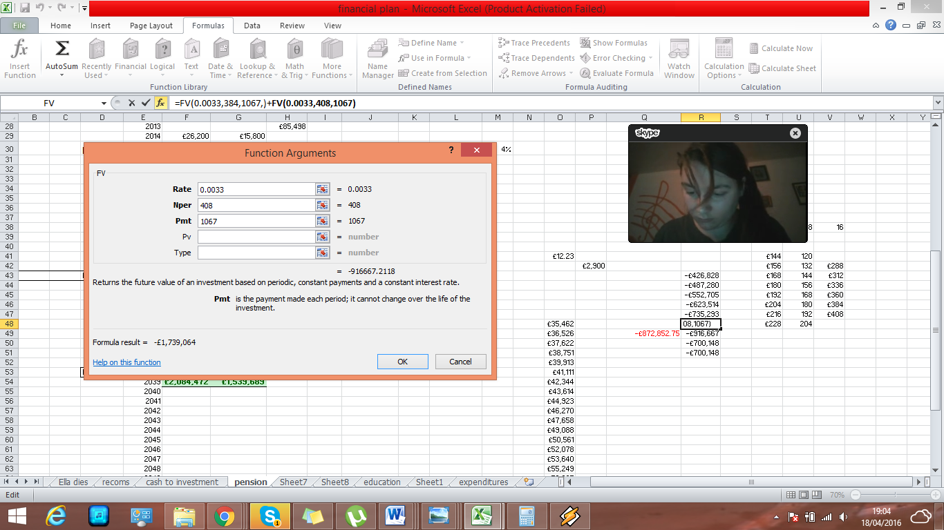  
4% APR is 0.33% per month, the amount of payments is months which is 408 (18 years * 12 months for Brian and 16 years * 12 months for Ella), £1067 per month is 21% of gross salary which is £12,810 at year 2016  
  
  
  
Step 3. Annuity Calculation   
The rate for annuity calculation is taken from HL (2016) for the annuity specified in the recommendations. To generate income of £35,000 or similar, the £2,900 must be multiplied by around 12 times as the income is specified for £100,000, therefore the fund value must be close to £1,200,000. By income for 384 months, the shortage is £822,397 with addition to difference of house downsizing in year 2033 (selling current property and buying retirement property, details in Appendix 5) and adding the cash to the fund would generate a total value specified in the recommendations.   
  
Appendix 5: House values linked to inflation:  


Appendix 6: Inflation Calculation:

Average taken from The Guardian (2016) document on historical inflation, Average of RPI was taken

References:

Ativa (2016), Sample Plan (Full Plan – all modules), Available from: <http://www.ativa.com/sample-plans/SamplePlan1.pdf> [Accessed 2.04.2016]

Bankers Investment Trust (2016), Bankers Investment Trust 8% Debenture Stock 2023, *Halgreaves Lansdown* [online], Available from <http://www.hl.co.uk/shares/shares-search-results/0087177> [Accessed 18.04.2016]

Barclays Bank PLC (2016), Barclays Bank PLC 9% Permanent Interest Bearing Bond, *Halgreaves Lansdown* [online], Available from: <http://www.hl.co.uk/shares/shares-search-results/0087025> [Accessed 18.04.2016]  
  
  
Bluefin Solar Income Fund (2016), Bluefin Solar Income Fund Limited (BSIF), *Halgreaves&Lansdown* [online], Available from: <http://www.hl.co.uk/shares/shares-search-results/b/bluefield-solar-income-fund-limited-ord-npv> [Accessed 4.04.2016]   
  
FPSB (2016), The Financial Planning Process, *Financial Planning Standards Board* [online], Available from: <https://www.fpsb.org/learnaboutfinancialplanning/financialplanningprocess.html> [Accessed 1.04.2016]

HL (2016), Best buy Annuity Rates, *Halgreaves Lansdown* [online], Available from; <https://www.hl.co.uk/pensions/annuities/annuity-best-buy-rates> [Accessed 18.04.2016]  
  
Ilmanen (2012), Expected Returns on Major Asset Classes, *CFA Institute* [online], Available from: <http://www.cfapubs.org/doi/pdf/10.2470/rf.v2012.n1.1> [Accessed 5.04.2016]

Gov.uk (2016), State pension age timetables, *Gov.uk* [online], Available from: <https://www.gov.uk/government/uploads/system/uploads/attachment_data/file/310231/spa-timetable.pdf> [Accessed 3.04.2016]

Legal and General Pension (2016), Legal&General Pension: Newton Multi-Asset Balanced Fund, *Funds Library* [online], Available from: <http://www.fundslibrary.co.uk/fundslibrary.dataretrieval/documents.aspx?user=landoc&type=custom_field.www_landg_co_uk.factsheet_SHD&sedol=3052138> [Accessed 18.04.2016]

Monevator (2016), A quick guide to asset classes, *Monevator* [online], Available from: <http://monevator.com/asset-classes/> [Accessed 18.04.2016]

Money Supermarket (2016), Life Insurance, *Money Supermarket* [online], Available from: <https://www.moneysupermarket.com/life-insurance/search/#/results/486891789291631357> [Accessed 5.04.2016] Note: May not be available as the search was done making an online quote for insurance policy]

Money Supermarket (2016), Income Protection Insurance, *Money Supermarket* [online], Available from: <http://www.moneysupermarket.com/income-protection/> [Accessed 18.04.2016]

The Guardian (2016), UK Inflation since 1948, *The Guardian* [online], Available from: <http://www.theguardian.com/news/datablog/2009/mar/09/inflation-economics> [Accessed 18.04.2016]

Wong (2016), Money Advice the Experts Don’t Agree On: Emergency Funds, *Two Cents* [online], Available from: <http://twocents.lifehacker.com/money-advice-not-everyone-agrees-on-emergency-funds-1589580471> [Accessed 4.04.2016]